-- Total number of Customers  
  
select count(\*) as 'Total Customers'  
from customertravel;



-- Total customers Churned  
  
select sum(Target) as 'Total Customers Churned'  
from customertravel;

Screenshot 2024-07-01 221007.png

-- Percentage of Churn Rate  
  
select (sum(Target)/count(\*))\*100 as 'Churn Rate'  
from customertravel;

Screenshot 2024-07-01 221152.png  
  
  
-- How many customers booked the Hotel services  
  
select count(\*) as 'Customers Booked the hotel'  
from customertravel  
where BookedHotelOrNot = 'Yes';

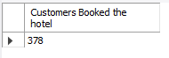  
  
  
-- What is the highest age of customers  
  
select max(Age) as'Highest Age'  
from customertravel;

Screenshot 2024-07-01 221812.png  
  
  
-- What is the lowest age of customers  
  
select min(Age) as'Lowest Age'  
from customertravel;

Screenshot 2024-07-01 221953.png

-- Categorize the customers based on their Age  
  
select \*, If(Age between 25 and 30, '25-30', If(Age between 30 and 35, '30-35', '35 Above')) as 'Age Category'  
from customertravel;

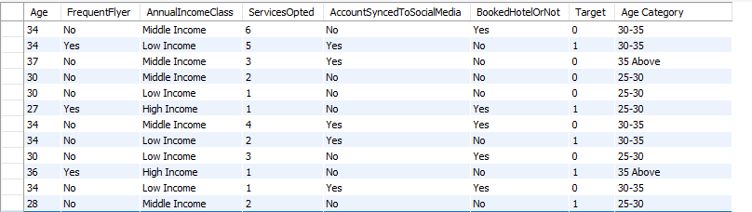

-- How many customers are frequent Flyers  
  
select count(\*) as 'Frequent Flyers'  
from customertravel  
where FrequentFlyer = 'Yes';



-- Highest number of services opted by a customer at once  
  
select max(ServicesOpted) 'Highest Number of Services opted'  
from customertravel;

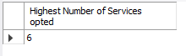

-- Lowest number of services opted by a customer at once  
  
select min(ServicesOpted) 'Lowest Number of Services opted'  
from customertravel;

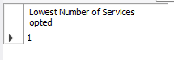

-- Average number of services as opted by each Age Category

with tab1 as (  
 select \*, If(Age between 25 and 30, '25-30', If(Age between 30 and 35, '30-35', '35 Above')) as 'AgeCategory'  
 from customertravel  
 )  
   
select AgeCategory, round(sum(ServicesOpted),0) as 'Services Opted'  
from tab1  
group by AgeCategory  
order by AgeCategory;

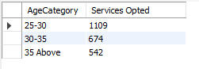

-- How many have their accounts synced to social medias  
  
select count(\*) as 'Customers with Accounts synced to Social Media'  
from customertravel  
where AccountSyncedToSocialMedia = 'Yes';

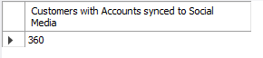

-- Is there any relationship between Hotel booking and Annual income of customers  
  
select distinct AnnualIncomeClass, count(BookedHotelorNot) as 'Hotel Booked'  
from customertravel  
where BookedHotelOrNot = 'Yes'  
group by AnnualIncomeClass  
order by 2 desc;

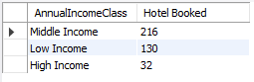

-- Customers with their Accounts synced to social media and their age  
  
with tab1 as (  
 select \*, If(Age between 25 and 30, '25-30', If(Age between 30 and 35, '30-35', '35 Above')) as 'AgeCategory'  
 from customertravel  
 )  
   
select AgeCategory, count(AccountSyncedToSocialMedia) as 'Accounts Synced'  
from tab1  
where AccountSyncedToSocialMedia = 'Yes'  
group by AgeCategory  
order by 2 desc;

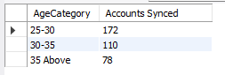

-- Customers Churned and their age category  
  
with tab1 as (  
 select \*, If(Age between 25 and 30, '25-30', If(Age between 30 and 35, '30-35', '35 Above')) as 'AgeCategory'  
 from customertravel  
 )  
   
select AgeCategory, count(Target) as 'Churn'  
from tab1  
where Target = 1  
group by AgeCategory  
order by 2 desc;

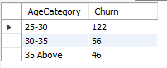

-- Customers Churned and their Annual Income Class  
  
with tab1 as (  
 select \*, If(Age between 25 and 30, '25-30', If(Age between 30 and 35, '30-35', '35 Above')) as 'AgeCategory'  
 from customertravel  
 )  
   
select AnnualIncomeClass, count(Target) as 'Churn'  
from tab1  
where Target = 1  
group by AnnualIncomeClass  
order by 2 desc;

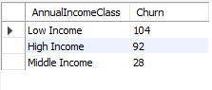

-- Number of Frequent Flyers categorised by Annual Income and Age  
  
with tab1 as (  
 select \*, If(Age between 25 and 30, '25-30', If(Age between 30 and 35, '30-35', '35 Above')) as 'AgeCategory'  
 from customertravel  
 )  
  
select AgeCategory, AnnualIncomeClass, count(FrequentFlyer) as 'Total frequent Fly'  
from tab1  
where frequentFlyer = 'Yes'  
group by AgeCategory,AnnualIncomeClass  
order by AgeCategory;

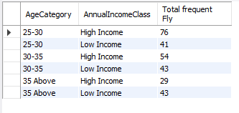

-- Find how many customers have frequently fly and Booked Hotels  
  
select count(\*) as 'Total'  
from customertravel  
where FrequentFlyer = 'Yes' and BookedHotelOrNot = 'Yes' ;

Screenshot 2024-07-02 100234.png

-- Out of the customers who frequently Flyed and Booked Hotels, what is the churn rate in percentage

select round(((select count(\*)  
 from customertravel  
 where FrequentFlyer = 'Yes' and BookedHotelOrNot = 'Yes' and Target = 1) / (select count(\*)  
 from customertravel  
 where FrequentFlyer = 'Yes' and BookedHotelOrNot = 'Yes'))\*100,2) as 'Churn rate';

